**PL SQL Task 22.11.2024**

**1)**Create a Stored Procedure that takes employee id as IN parameter and updated salary as OUT parameter.

Then update the salary of the employee

Before Update:

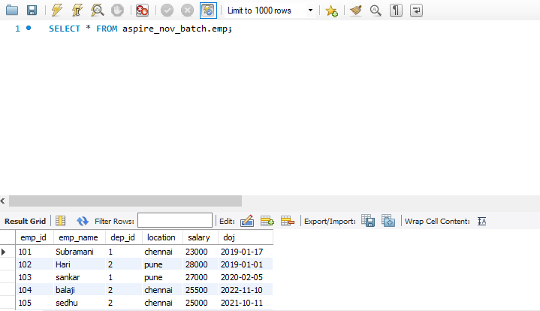

After create procedure and updated:

delimiter //

create procedure get_UpdatedSalary(in id int,out updated_salary numeric)

begin

declare current_salary numeric;

select salary into current_salary from emp where emp_id = id;

set updated_salary = current_salary +2500;

update emp set salary = updated_salary where emp_id = id;

end;//

call get_UpdatedSalary(101,@emp);

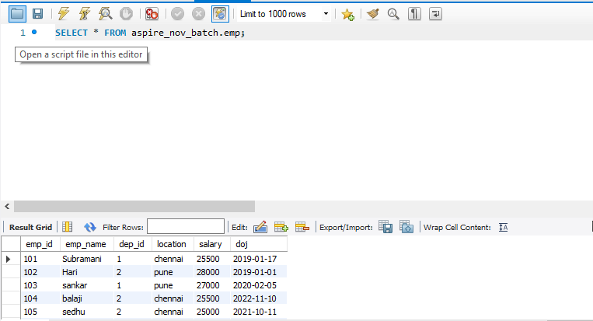

2)Create a function that takes location as an argument and display the details of

all employees in the specified location.

delimiter //

create function get_employeeDetails(loc varchar(50))

returns boolean

deterministic

begin

drop temporary table if exists temp_table;

create temporary table if not exists temp_table as

select * from emp where location = loc;

return true;

end //

delimiter ;

select get_employeeDetails('chennai');

select * from temp_table;

Chennai location :

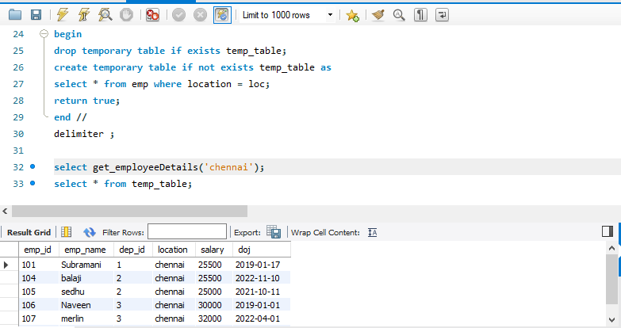

Pune location:

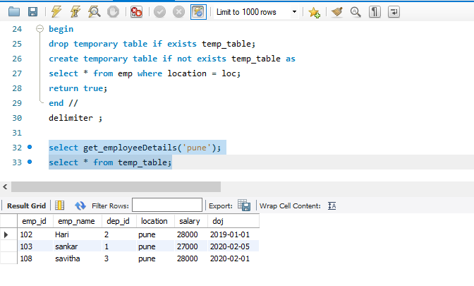

3)Create a view to display the employeeId, departmentname of all employees in "TN" and "TA" departments who joined in 2022

create view fetch_employee as

select emp.emp_id,department.dept_name from emp join department

on emp.dep_id = department.department_id

where department.dept_name in('TN','TA') and year(emp.doj) = 2022;

select * from fetch_employee;

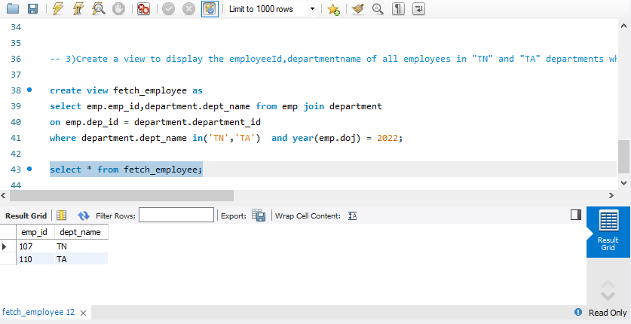

4)Create a trigger that fire After insertion in the employee table by updating the count in the department

delimiter //

create trigger get_trigger

after insert on emp

for each row

begin

update department

set emp_count = emp_count+1

where department_id = new.dep_id;

end; //

select * from emp;

insert into emp values (113,'arjun',1,'chennai',34000,'2020-04-04');

select * from department;

Before inserting new record ‘ES’ :

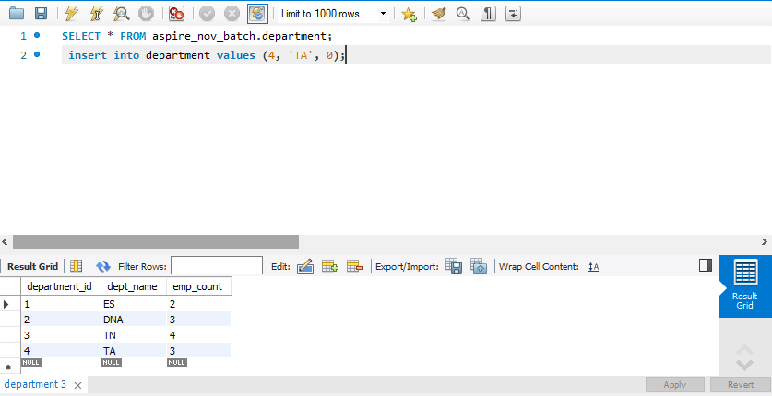

After inserting new record ‘ES’:

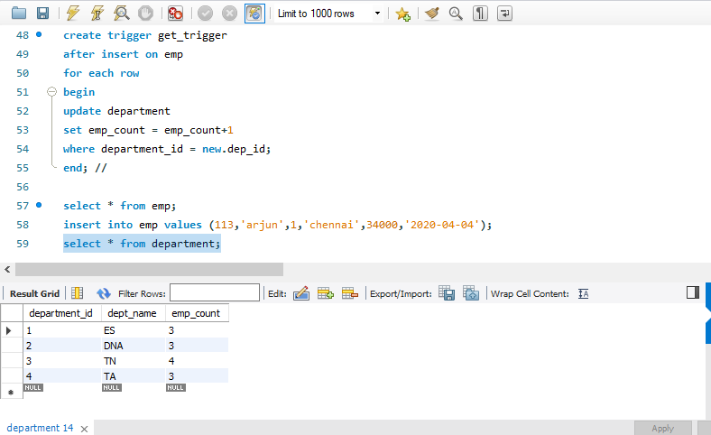

5)Create a trigger that fire after update salary in the employee table. Store the updated employee details in another table

delimiter //

create trigger store_anotherTable

after update on emp

for each row

begin

if old.salary <> new.salary then

insert into updatedsalaryetails (emp_id, emp_name, dep_id, location, old_salary,new_salary, doj)

values (new.emp_id, new.emp_name, new.dep_id, new.location, old.salary, new.salary, new.doj);

END IF;

end //

update emp

set salary = 27000 where emp_id = 112;

select * from updatedsalaryetails;

